|  |
| --- |
| University of Waterloo |
| Completed Sensor Fusion System |
| MTE546 – Multi-Sensors Data Fusion |
|  |
| **Ziyang Huang (20484627)** |
| **3/26/2018** |

1. Simulation – IR Sensor

In the simulation for IR sensors, they are set to detect the distance to the edges of the heat source. The schematic below shows the setup for the IR sensors, heat source and the aluminum plate.

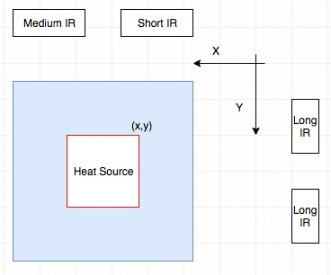

Figure 1. Schematic for the setup for the IR sensors, heat source and the aluminum plate.

For short and medium IR sensors, it is set to 8 cm away from the edge of the aluminum plate. For long IR sensors, it is set to 20 cm away from the edge of the aluminum plate. When calculating the distance, we take the measurement voltage value for the sensor model in order to find the distance. To determine the location, we subtract the original distance with the distance between the edge and the sensor, and then take the average for each pair of sensors. As a result, we would get a (x,y) coordinate for the edge of the heat source.

For the occupancy grid, the size is set as 10 by 10. To fill up the occupancy grid, we set a rule as is:

P(detected edge)=P(x,y)=P(x,y+1)= P(x,y+2)= P(x+1,y)=P(x+1,y+1)=P(x+1,y+2)= P(x+2,y)= P(x+2,y+1)=P(x+2,y+2)=0.9

P(not detected)=0.5.

We set three different cases: heat source is set around the centre, heat source is set on one of the edge, heat source is set on the edge and part of the heat source is out of the edge. Figure 2-4 shows the results of the simulation for three different cases.

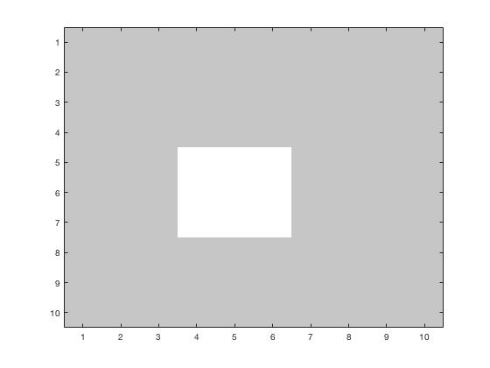

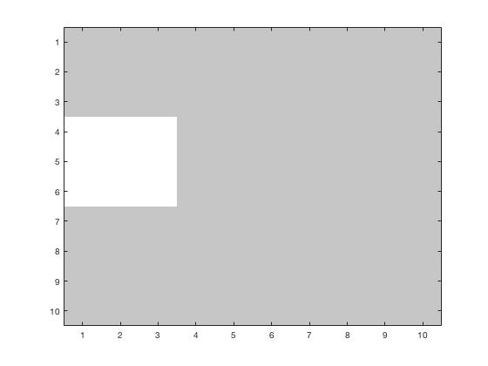

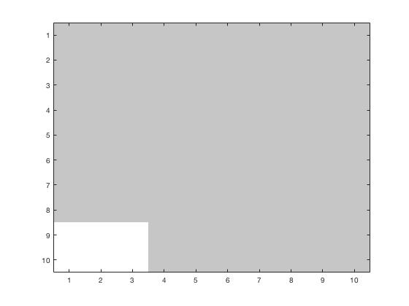

Figure 2-4. Results of the simulation for three different cases.

Based on the simulation, as we could determine the distance between the heat source and the sensors, we could determine the rough location for the heat source. Based on the rule we set on filling the occupancy grid, the simulation could handle such three cases.

1. Simulation – Thermocouple

In the simulation for IR sensors, they are set to detect the temperature. The schematic follows the setup from the lab manual. We set the occupancy grid size as 10 cm by 10 cm. Before filling up the occupancy grid, we assume the temperature gradient is 0.2 degree/cm. After that we create temperature map by the rule:

$$T=T_{measurement}+n*∆t, where ∆t=0.2 degree/cm and n=\# of grids.$$

we assume a maximum temperature Tmax for the source when operating. Once we create the five temperature maps from 5 measurement point, we compare the temperature value from each grid of each map to the maximum temperature. To fill the temperature map, we choose the value which has the smallest absolute difference to the maximum temperature. After that, we will fill the grid with these rules:

P(|Tmax-T(i,j)|<=0.1)=0.9

P(0.1<Tmax-T(i,j)<=0.15)=0.7

P(temperature difference not on certain range)=0.5.

The test cases will be the same cases on Section 1.0. Figure 5 to 7 shows the result for three different cases.

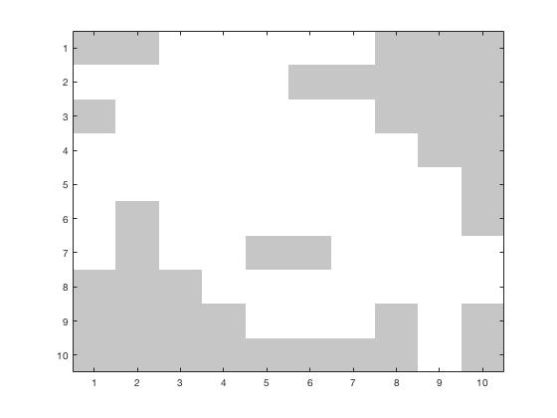

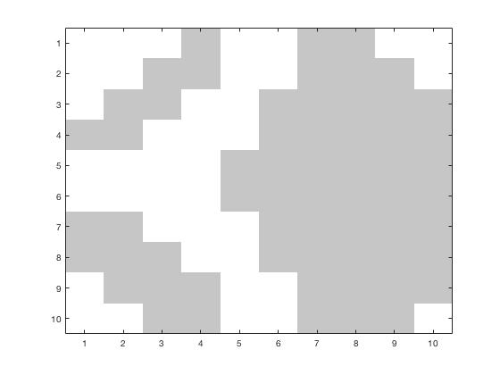

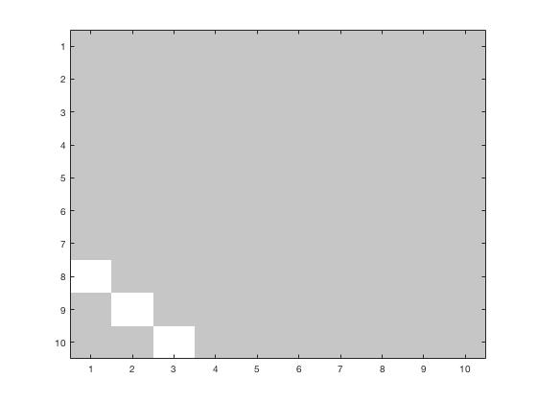

Figure 5-7. Results of the simulation for three different cases.

Based on the simulation, as we could determine the temperature we could determine the rough location for the heat source. However, since the temperature for simulation has a great uncertainty, it will present a lot of outliers or do not present the location clearly. Therefore, it is necessary to verify the measurement data and/or use the combination fusion system.

1. Simulation – IR Sensor and Thermocouple Combination

In this simulation, we make a multiplication on the probability from each grid on occupancy grid maps created by IR sensor and thermocouple. The test cases will be the same cases on Section 1.0. Figure x to x+2 shows the result of the combination of the system for three different cases.

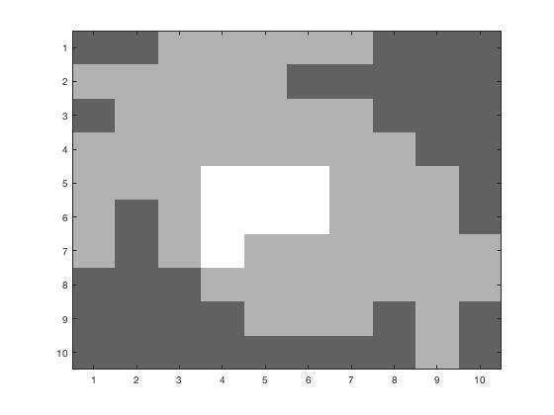

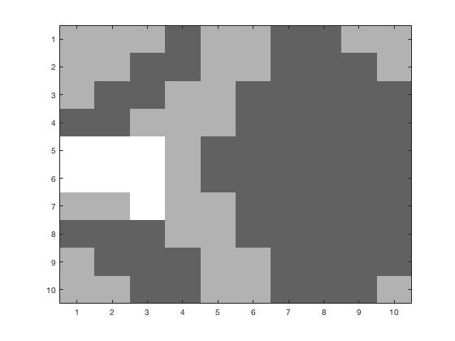

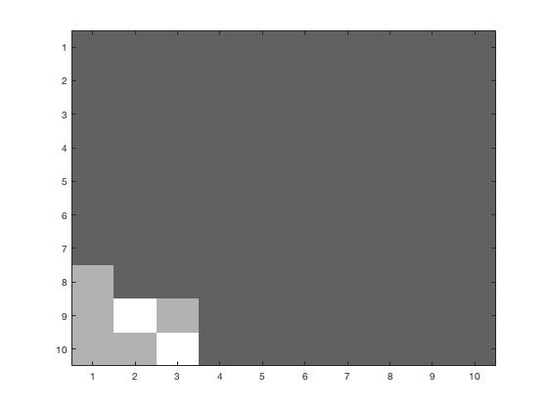

Figure 8-10. Results of the simulation for three different cases.

For the combined system, since the measurement is one-time step only, it does not take too much time to respond. However, since the combined system includes more loops to calculate and mapping, it will take more time for larger set of data.

For the advantage of the combined system, it will be more accurate to locate the centre of the heat source. However, it will create a bigger localization map with bad data from thermocouple and IR sensors, which will be the disadvantage of the combined system.

1. Experimentation Setup

In the experimentation, the setup is shown as Figure.11.

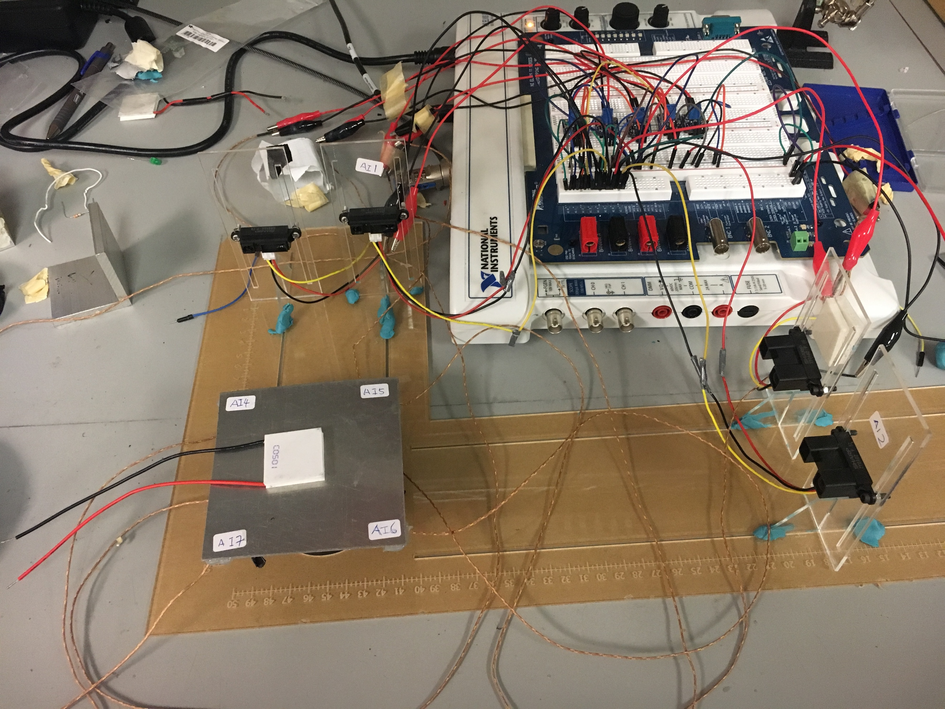

Figure 11. Experiment Setup.

For temperature reading, we wait for 1 minute to heat up and take the value when the temperature is relatively steady (the aluminum plate does not get heat up any more). We set two different cases: heat source is set on the centre, and heat source is set on one of the edge. The test case setup is shown as Figure.12-13.

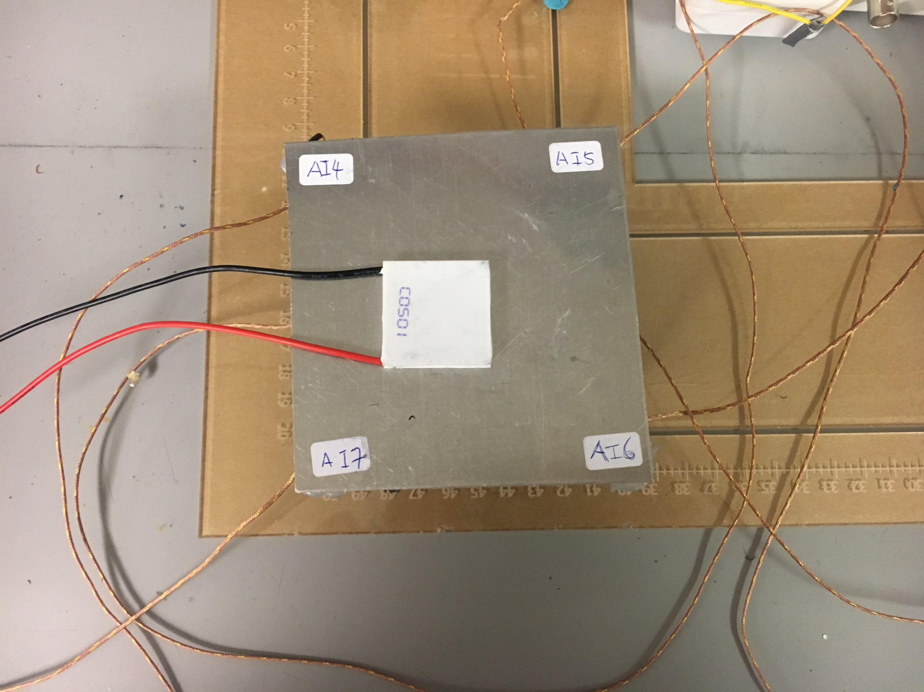

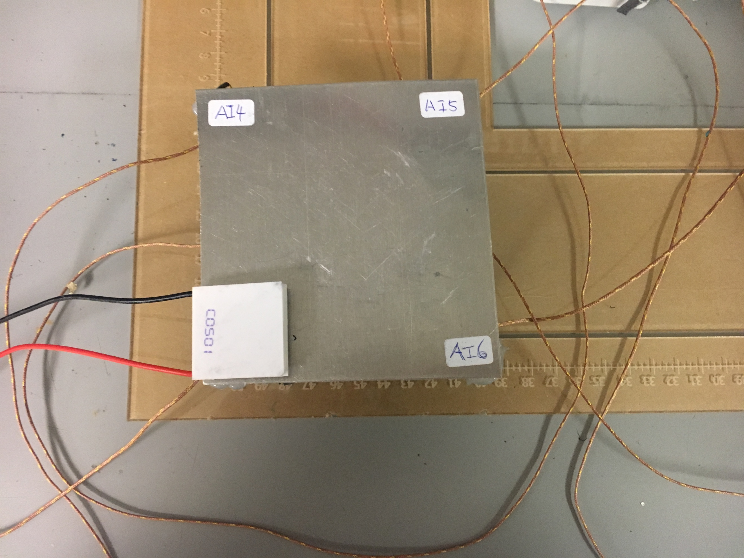

Figure 12-13. Test cases for different locations for heat source

1. Experimentation – IR Sensor

Using the data from measurement, Figure 14-15 shows the result for two different cases with IR sensors only.

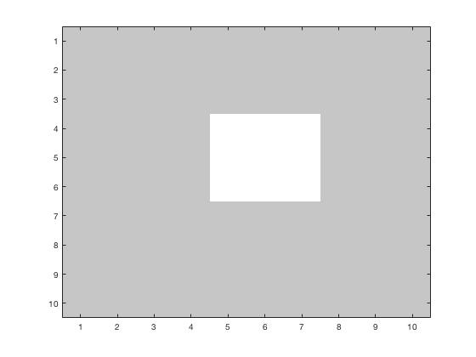

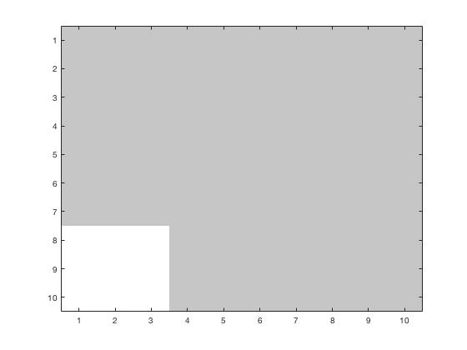

Figure 14-15. Experiment result for two cases with IR sensor only.

Compared the simulated result and the experiment result, it shows that the measurement from IR sensor is roughly matched the exact location. However, due to the noise, it could not locate the exact location for the heat source. Also, since we set up a relatively large size on the occupancy grid, we would expect to have around 1cm offset from the experimental result to the simulated result.

1. Experimentation – Thermocouple

Using the data from measurement, Figure 16-17 shows the result for two different cases with thermocouple only.

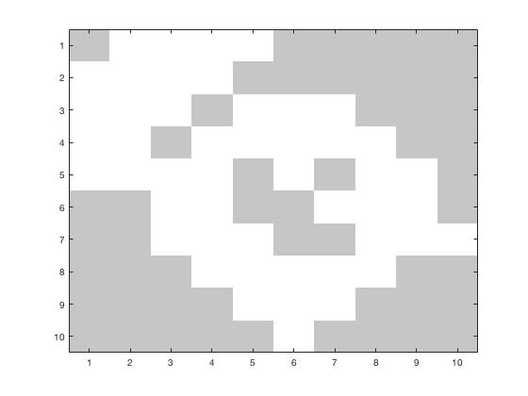

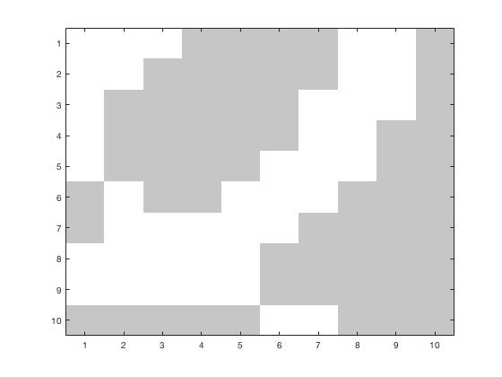

Figure 16-17. Experiment result for two cases with thermocouple only.

Compared the simulated result and the experiment result, it shows that the experiment result shows the rough location for the heat source. Similar to the simulated result, the experiment result has lots of outliers. To exclude to outlier, we are going to combine both sensors and thermocouple.

1. Experimentation – IR Sensor and Thermocouple Combination

Using the data from measurement, Figure 18-19 shows the result for two different cases.

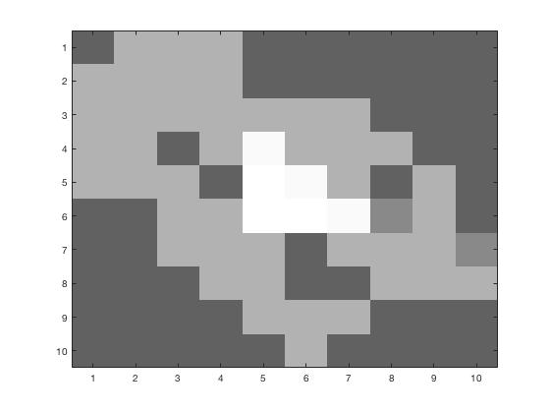

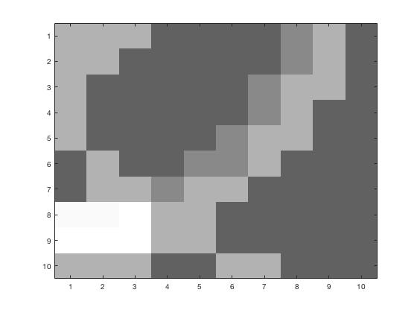

Figure 18-19. Experiment result for two cases with combined system.

Compared the simulated result and the experiment result, it shows that the combined system could show a more accurate location for the heat source. Compared with the simulated result, we could obtain similar result from experiment.

The cost associated with using the fused system is to take time to set up the testing environment (waiting for heating up) and validate the measurement data. Also, it takes longer time to compute the map. What is more, we have to obtain the maximum temperature value that we could measure for the heat source before doing localization simulation and experiment. As a reward, we could obtain a higher accuracy result of localization.